Data Ingestion Framework
Introduction:
Data ingestion framework is an architecture for designing and creating data ingestion pipelines in AWS infrastructure for extracting data needed for ARC 2.0 application from various input data sources.
Statement of scope:
- Data ingestion will handle data storage in s3 (Raw layer). Based on user input for partitions.
- Data ingestion will maintain data quality in storage which will always be in input source based on refresh times.
- Data ingestion will handle incremental / full refresh of data refresh.
- Data ingestion will give options to users on schedule for data refresh.
Based on above responsibilities Data ingestion framework will also addresses the existing pain points in BDE environment.
A vision of Data Ingestion framework:
The ultimate vision of data ingestion framework is to be packaged solution for anyone who likes to pull data from different sources starting with databases (Oracle) in v1 release.
Use Cases of Data Ingestion:
- Extract data from BIDW data source.
- Extract data from DARBA data source.
Pain points:
- Complex data incremental data pipeline development for incremental refresh.
- Data quality issues (Data duplicates) when doing refresh.
- Managing data at record level in Amazon S3 data lakes for faster updates / deletion of s3 records.

Design Guidelines:
- We use native AWS components.
- We use Python 3 for code.
- We maintain all our ETL code in source control.
- AWS EMR and AWS Glue for ETL Jobs.

Architectural Designs:
Using Apache HUDI:
Apache Hudi is an upsert engine.
https://hudi.apache.org/
https://docs.aws.amazon.com/emr/latest/ReleaseGuide/emr-hudi-how-it-works.html
- Why is it useful
Simply incremental data processing and data pipeline development. Hudi enables you to manage dara at the record level in Amazon S3 data lakes. Data sets managed in Hudi are stored in S3 using open storage format, while integrations with Presto/Athena, Apache Hive, Apache Spark and AWS Glue Data Catalog gives your near real time access to updated data using familiar tools.
HUDI is natively supports by EMR and AWS Glue(Glue version > 3.0).
    - Specifics of how the data is laid out as files in these S3 directories depends on the Hudi dataset you choose.
        - Copy On Write (CoW)
        - Merge on Read(MoR)
- Which Hudi dataset to choose
- Copy on Write(CoW): Data is stored in columnar format(Parquet), and each updates creates a new version of files during a write. Cow is the default hudi storage type.
- Merge on Read(MoR): Data is stored using a combination of columnar(Parquet) and row-based (Avro) formats. Updates are logged to row based delta files and are compacted as needed to create new versions of columnar files.
- With CoW datasets, each time there is a update to a records, the file that contains record is rewritten with the updated values. With MoR datasaet, each time there is an update, Hudi writes only the row for the changed record. MoR is better suited for write- or change-heavy workloads with fewer reads. CoW is better suited for read-heavy workloads on data that changes less frequently.

- Integration with EMR
With Amazon EMR by default installs Hudi components when Spark, hive is installed.
Works with Apache Hive/ AWS Glue Data catalog.
- Integration with Glue
AWS Glue 3.0 and later supports Apache Hudi framework work data lakes [1].
Works with AWS Glue Data catalog.
Limitations:
- Works with Glue data catalog seamlessly (For Hive need to understand workaround on how to connect to EMR Hive from Glue).
- Doesn’t support Merge on Read (MoR) dataset.
Data Lake with Hudi architecture
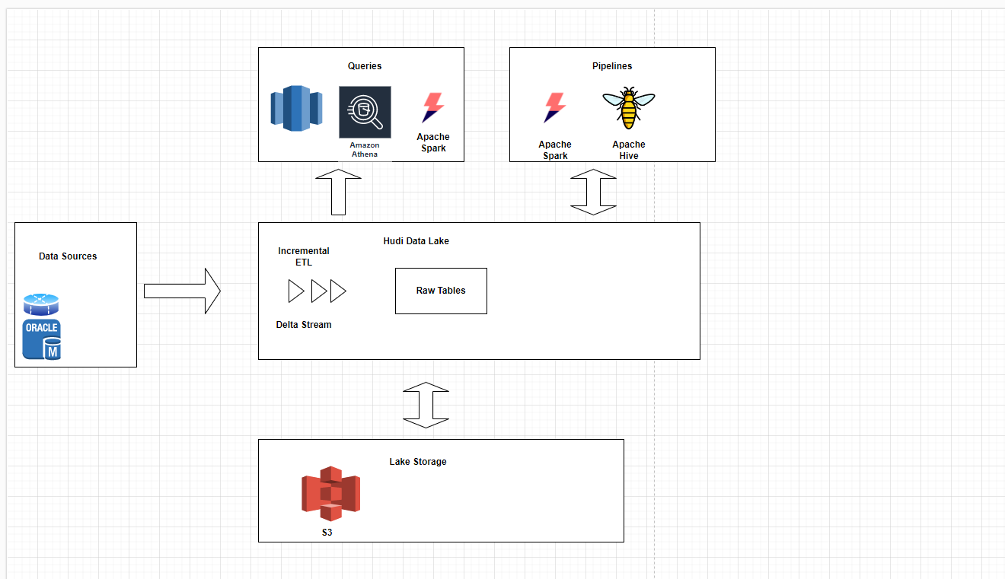
Option 1
Using EMR + Hive
POC(Single table using EMR to pull data and query in Hive)
Option 2
Using Glue + Glue Data Catalog
POC(Single table using AWS Glue to pull data and query in Hive)

Appendix
[1]: https://docs.aws.amazon.com/glue/latest/dg/aws-glue-programming-etl-format-hudi.html

